[](http://school.discoveryeducation.com/clipart/clip/student-news-color.html)The Kashatus Chronicle

Check out our class web page

mrskashatus.weebly.com Monday, October 3, 2011

*Thanks so much to all of the parents who helped with our globe project! They look terrific! *

*Please remember that parents are invited to attend an Open House next Monday.*

*Look for information in Wednesday’s information packet.*

*We are in the middle of another great week,* Mrs. Kashatus

____________________________________________________________________________________________

WELCOME!

*Wood Acres Elementary School welcomes Mrs. Ashton, our new assistant principal to our community!*

Mrs. Ashton has been Assistant Principal for six years. She has 2 daughters. Their names are Kelsey, who is 12, and Kennedy, who is 9. They go to a Catholic school called St. Pius Elementary. She has visited Hawaii and London.

Her favorite subject is reading. She likes reading because she learns new things, new words and it improves her creativity. **Her favorite books are Stand Tall, Molly Lou Melon and Color Me Butterfly.**

She likes Wood Acres because she meets new kids and their parents and she likes to check in classrooms. She hopes to help Mrs. King with the peace program to make Wood Acres the best we can be.

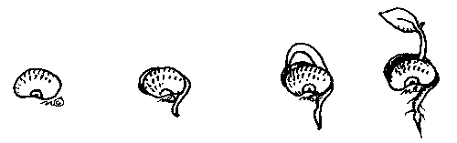**- By Yipu and Lily**

Science

Every plant has grown by now! Some even have buds! We’ve measured the plants and some are now 3-4 inches long. Everyone is so excited! We made Bee sticks and we are pollinating our plants.

We are hoping to earn an ant farm soon! *-By Scout*

Little John

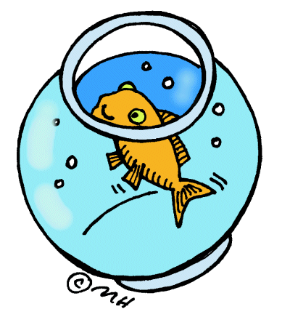 Little John now has his *beta bulbs* sprouting in his bowl. I think he doesn’t even know they are there. I also think we should change the water in his bowl. But I really want the betta bulbs to start becoming plants sooner. *-By Juliana*

**Weather for the week of October 3-7** *-By Jessica*

|  |  |  |  |  |
| --- | --- | --- | --- | --- |
| MON. | TUES. | WED. | THURS. | FRI. |
| C:\Users\kashatuc.MCPSMD.016\AppData\Local\Microsoft\Windows\Temporary Internet Files\Content.IE5\X5VP58M2\MC900438251[1].wmf | C:\Users\kashatuc.MCPSMD.016\AppData\Local\Microsoft\Windows\Temporary Internet Files\Content.IE5\X5VP58M2\MC900432587[1].png | C:\Users\kashatuc.MCPSMD.016\AppData\Local\Microsoft\Windows\Temporary Internet Files\Content.IE5\RD25QRHT\MC910217033[1].png | C:\Users\kashatuc.MCPSMD.016\AppData\Local\Microsoft\Windows\Temporary Internet Files\Content.IE5\RD25QRHT\MC910217033[1].png | C:\Users\kashatuc.MCPSMD.016\AppData\Local\Microsoft\Windows\Temporary Internet Files\Content.IE5\RD25QRHT\MC910217033[1].png |
| 58° | 67° | 72° | 67° | 70° |
| 45° | 50° | 47° | 45° | 49° |
| Rain 90% | 10% | 0% | 0% | 0% |

Social Studies

Our World’s Continents

My name is Eva and I am going to tell you about what we are doing in Social Studies. We are making globes using paper mache. We started with a balloon, thick glue, newspaper and a towel. First you protect the table with newspaper or a towel. Then put a balloon on the table with the glue and strips of newspaper. Then you dip the paper in the glue, strip the extra glue off, and smooth it on your balloon until it is covered completely. After it dries, we will make it blue like the sea. Then we will glue our continents on it. Thank you, parents, for helping us to complete this project! - By Eva

South America Celebration

To celebrate our success of getting compliments we had a pajama party and watched Rio the movie and learned about South America with our word searches with a few helping hands from the South America table. -By Thiago

Math

In Ms. McGee’s class, we are working on graphing, median and mean. It is like a puzzle. Median is hard. Until Wednesday, we will be working on the Ten Friends strategy. –By Zachary L.

In Mrs. Noenickxes class, we are learning about graphing, minimum, maximum, mode, range, mean and median. Maximum is the biggest and minimum is the smallest. We did a ton of work with sets then on Tuesday we learned about mode and range. On Wednesday, we had our Robin Hood Quiz and learned about median. –By Becca

In Mrs. Kashatus’ class, we are become experts at using the partial sums and the Trade-First methods.

-By Joshua

**Basic Fact Tens Friends Quiz**

**Wednesday, October 5, 2011**

Reader’s Workshop

[](http://school.discoveryeducation.com/clipart/clip/bookworm.html)**Realistic Fiction**

We have been meeting in book clubs during Reader’s Workshop. In book club we read a book, or some of it, and then we write a summary and write down some questions about that part of the book. In *Spelling*, we are playing a game called Guess the Covered Word. We make a sentence and one of our word wall words has to be in the sentence. The sentence has one blank. When you are done, you can ask anybody if they want to guess what the blank is. *Language Arts* is fun in third grade.

By Sammy

Writers Workshop

We are sharing at the work of Newberry Award winner Cynthia Rylant. We have learned that her personal life experiences inspire her writing. As we study her craft, we are revising our own memory writing.

Art, Music and P.E.

P.E.

In P.E., we played octopus for our warm up. Then, after octopus, we played two-ball –soccer. The reason we play with two balls is that more people get to dribble the ball. Everyone played well. Some of the people who scored were Ally, Sammy and Brendan S. –by Ally

Music

This week in Music, we sang *Washing-machine*. We made up a dance to go with it. It was so funny! In the beginning of the song there was a deep voice. It was like “Blah, blah, blah.” We got a letter. That’s good. This has been Jacqueline telling you about Music. *-By Jacqueline*

[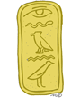](http://school.discoveryeducation.com/clipart/clip/kartouche-color.html)Art

Every week on Wednesday, we have Art. This week we made hieroglyphics out of clay. It was very messy. Mine had my animals on it. It is something I will really remember! *-By Josie*

BMX Assembly

[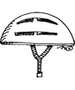](http://school.discoveryeducation.com/clipart/clip/bkehlmt2.html)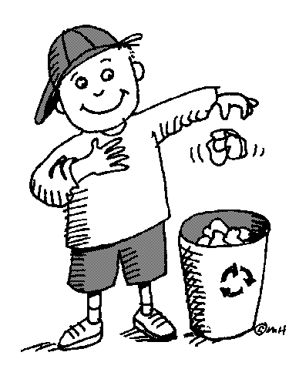Recently, we had an assembly which was about bicycle safety. The person who did was a pro BMX rider! He did tricks then told us about bicycle safety. Then he did more tricks and then told us a story about how he got interested in doing trick on bicycles. Also the pro BMX rider’s name was Rich. For his last trick he jumped over two teachers! The whole assembly was really cool.

By Matthew

**Bud**

Bud

A tiny velveteen satchel,

the color of pale cream,

is perched on the tip

of this bare branch.

Snap open the clasp-

and you will find,

inside this tiny valise,

one rolled and folded

neatly packed

leaf.

-Kristine O’Connell George

from *Old Elm Speaks*

tine O’Connell George

From *Old Elm Speaks*

Green Team

-By Natalie and Maito

This is what happens in Green Team… you go to each room in the school and you take the recycling bin with paper in it and we put that paper in the bigger recycling bin. Mr. Walker takes the big one outside so the recycling truck can pick it up.