[](http://school.discoveryeducation.com/clipart/clip/student-news-color.html)The Kashatus Chronicle

Check out our class web page

mrskashatus.weebly.com Monday, October 10, 2011

*School Pictures are scheduled for Thursday, October 13 at 2:00*

*We are looking forward to another great week,* Mrs. Kashatus

Open House

Monday, October 10, 2011

## Welcome Parents!

Science

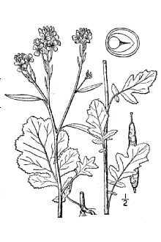

*More of our Brassica plants have bloomed. We continue to pollinate them. We are starting to see the pods.*

*–By Eva*

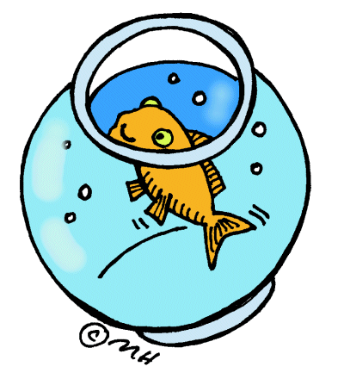Little John

Little John’s bowl is still clean. His bulbs are floating and they are still growing. He likes to hide in them. -By Juliana

**Weather for the week of October 10-14**

|  |  |  |  |  |
| --- | --- | --- | --- | --- |
| MON. | TUES. | WED. | THURS. | FRI. |
| C:\Users\kashatuc.MCPSMD.016\AppData\Local\Microsoft\Windows\Temporary Internet Files\Content.IE5\Q6LT7BM1\MC900432587[1].png | C:\Users\kashatuc.MCPSMD.016\AppData\Local\Microsoft\Windows\Temporary Internet Files\Content.IE5\AL4S43TY\MC900441809[1].png | C:\Users\kashatuc.MCPSMD.016\AppData\Local\Microsoft\Windows\Temporary Internet Files\Content.IE5\Q6LT7BM1\MC900438251[1].wmf | C:\Users\kashatuc.MCPSMD.016\AppData\Local\Microsoft\Windows\Temporary Internet Files\Content.IE5\AL4S43TY\MC900440407[1].png | C:\Users\kashatuc.MCPSMD.016\AppData\Local\Microsoft\Windows\Temporary Internet Files\Content.IE5\AL4S43TY\MC900432587[1].png |
| 79° | 73° | 67° | 72° | 68° |
| 58° | 62° | 58° | 57° | 52° |
| Rain 0% | 10% | 70% | 30% | 20% |

*-By Jessica*

[](http://school.discoveryeducation.com/clipart/clip/clrglobe.html)

Social Studies

Our World’s Continents

Joel’s mom came in and she spoke about where they are from and she showed us two posters that she made about New Zealand and Australia. She gave us things to try, including kiwi, fruit leather and marmite on crackers! Joel showed us a rugby ball and told us how to play rugby. He also brought in stuffed animals from New Zealand.

We added the prime meridian and equator on our globes. We also added the continents and labeled the oceans. -By Lily

Math

In Mrs. Kashatus` math we are studying graphs and partial sums and trade first subtraction.

In Mrs. McGee`s math class we are studying stem and leave and partial sums. We`re going to study multiplication and division and we`re also studying trade first and graphs and compasses in math geometry tangrams, place value, addition fractions.

In Mrs. Noenickx`s class we are studying land marks, subtraction, addition, trade first and regrouping and partial sums. -By: Peter & Brendan .S & Scout

**Basic Fact Quiz: Nines**

**Wednesday, October 12, 2011**

[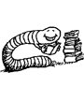](http://school.discoveryeducation.com/clipart/clip/bookworm.html) Reader’s Workshop

**Realistic Fiction**

I am going to tell you about book club and what realistic fiction means. So, in book club my classmates and I are reading The Lemonade War. The book is realistic fiction and that means that if the author writes a book about a boy going to a baseball game with his dad ,that could really happen. So that’s what realistic fiction means. Before, I was talking about booik club , in our book the author wrote about a little girl and her older brother were having a lemonade stand and were going against each other. That could really happen. That is what book club is about and what realistic fiction means. –By Katelyn

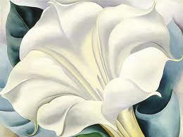

**Bud**

Bud

A tiny velveteen satchel,

the color of pale cream,

is perched on the tip

of this bare branch.

Snap open the clasp-

and you will find,

inside this tiny valise,

one rolled and folded

neatly packed

leaf.

-Kristine O’Connell George

from *Old Elm Speaks*

tine O’Connell George

From *Old Elm Speaks*

Writers Workshop

We are doing a cool new thing called Mystery Word. This is how you do it:

First, Mrs. Kashatus gives us a big word that is scrambled and we have to try to figure it out. We are givien a sheet of paper and before we find out the mystery, we try to find as many words as possible that can be written with the letters. Ourt class has already done two mystery words. Th ewords were *hieroglyphics* and *sarcophogus!* (Art connections) I had a little trouble figuring them out but I finally did! –By Sammy

We are writing new poems about colors. We are using our senses to describe images.

Art, Music and P.E.

Art

This week in art, my class learned about Georgia O’Keefe. We learned about her artwork. Then, we sketched flowers. (She drew flowers) This week, I think our class might paint a picture of a flower, like Georgia O’Keefe. I can’t wait till’ Wednesday!!!-By Josie

P.E

In P.E. we ran 10 laps around the gym Then we played in centers they were jump roping, swinging on the ropes, roller racers, we played with medicine balls and we also did other things .we got to pick who was in our group. Most of the groups are just all boy or just all girls.

- By Becca and Ally

Music

Last week in music class, we played a song called Mountain. We used the music books and played it on the xylophone. It was so fun. We earned a letter! -By Jacqueline