[](http://school.discoveryeducation.com/clipart/clip/student-news-color.html)The Kashatus Chronicle

Check out our class web page

mrskashatus.weebly.com Monday, October 17, 2011

*No School on Friday, October 21st!*

*Please remember to return permission slips and checks for our field trip!*

Math

In Mrs. Kashatus` math we are studying graphs and partial sums and trade first subtraction.

In Mrs. McGee`s math class we are studying geometry. Mrs. Noenickx`s class is starting geometry, too. All of the classes are studying leftovers for their basic facts. In two weeks we will be having a big basic fact quiz!

-Ally

**Basic Fact Quiz: Leftovers**

**Wednesday, October 19, 2011**

[](http://school.discoveryeducation.com/clipart/clip/clrglobe.html)

Social Studies

Regions of the World

We are writing about Social Studies. Since we have finished learning the basics about the continents, we are going to start learning about five regions. The Sahara dessert is the most famous desert, while Greenland, Antarctica and the North Pole are tundras. Grasslands are places full of grass. For example, a plain is full of grass so it is considered grassland. A rainforest is like a forest but most of the time it is wet. The Amazon rainforest is a very big and famous rainforest. Last but not least, a deciduous forest is a forest in which trees lose their leaves in winter.

– By Sammy and Katelyn

We will start meeting in expert groups on Wednesday, October 19th!

Science

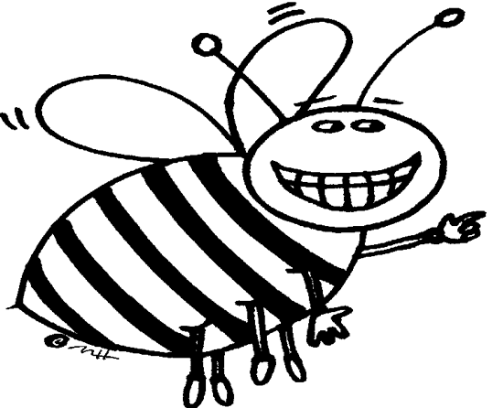

***Are you working on your Bee Project? You should bee! It is due November 1st!***

We continue to learn about pollinators. Ask us about some of the other animals that pollinate.

We have also started to read about migration, one adaptation animals use to survive. We will connect this to our *regions* research.

**Weather for the week of October 17-21**

|  |  |  |  |  |
| --- | --- | --- | --- | --- |
| MON. | TUES. | WED. | THURS. | FRI. |
| C:\Users\kashatuc.MCPSMD.016\AppData\Local\Microsoft\Windows\Temporary Internet Files\Content.IE5\Q6LT7BM1\MC900432587[1].png | C:\Users\kashatuc.MCPSMD.016\AppData\Local\Microsoft\Windows\Temporary Internet Files\Content.IE5\Q6LT7BM1\MC900432587[1].png | C:\Users\kashatuc.MCPSMD.016\AppData\Local\Microsoft\Windows\Temporary Internet Files\Content.IE5\Q6LT7BM1\MC900438251[1].wmf | C:\Users\kashatuc.MCPSMD.016\AppData\Local\Microsoft\Windows\Temporary Internet Files\Content.IE5\G80S5G73\MP900433163[1].jpg | C:\Users\kashatuc.MCPSMD.016\AppData\Local\Microsoft\Windows\Temporary Internet Files\Content.IE5\AL4S43TY\MC900432587[1].png |
| 72° | 71° | 66° | 60° | 59° |
| 52° | 60° | 53° | 46° | 43° |
| Rain 10% | 20% | 60% | 10% | 10% |

*-By Jessica*

[](http://school.discoveryeducation.com/clipart/clip/bookworm.html)

Reader’s Workshop

**Realistic Fiction**

I am Josie Wolfe, and I am going to tell you about reading (Book club). The book I am reading is Because Of Winn Dixie. It is a good book. There have not been any special things that have happened, and I don’t think there will be. The groups that people are in are the Amber Brown group, the Face Off group, the Ramona group, The Lemonade War group, the Winn-Dixie group, And the Henry and Mudge group. They are all realistic fiction. That is my article in the Kashatus Chronicle! ☺

Book Reviews

The 39 Clues

Recently we got the 39 clues box set. I have read the whole series. Now here are some other people’s opinions about the book. “It’s great! I love it!” says Peter Godschalk, age 8. Peter is currently on the 8th. Also Zach Safford , age 8 says, “It’s a great series.” Zach is currently on the 9th book and book 4 is his favorite.

-By Matthew

This is live from the Kashatus Chronicle were talking about a very popular book in are class it is called THE PECULIAR PUMPKIN THIEF, by Geronimo Stilton. It’s about a clown named Chuckles and a detective named Hercule and, of course, Geronimo Stilton. Be sure to read this crazy adventure. This report is by Jacqueline & Lily !!!!!!!!:)

Writers Workshop

Our color poems are up. They are terrific!

Art, Music and P.E.

Art

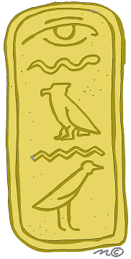In art, we painted our cartouches in watercolors and pretty gold paint. I think everybody is going to love their artwork.

Everybody’s is different in a way. –By Becca

P.E

In P.E. we are doing exercise centers: climbing the rope, squats, jump rope, helicopter, pushups and pass with a pound ball. We are trying to get the show award. Please remember to wear sneakers! –By Brendan B.

Music

We used the xylophones and earned a letter.- Maito

The annual Wood Acres Halloween Parade is scheduled for Friday, October 28th at 1:45. Our class party will follow!