[](http://school.discoveryeducation.com/clipart/clip/student-news-color.html)The Kashatus Chronicle mrskashatus.weebly.com Friday, November 4, 2011

**Special Halloween and Field Trip Edition**

Check out our class web page

*Remember that Parent Teacher Conferences are scheduled for Thursday and Friday. Please be sure to confirm your conference time or contact me to reschedule (Reminders went home 11/1).*

*I’d like to thank all of the parents who helped to plan our wonderful Halloween party. We all had a GREAT time!*

*Thank you, also, parents who chaperoned for our field trip! Finally, thank you parent volunteers who are helping with our Regions research! Your continuing support is so appreciated! –Mrs. Kashatus*

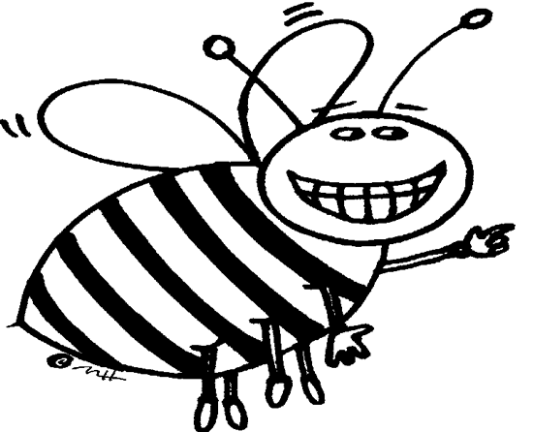Science

What’s the BUZZ about Bees?

-By Scout, Josie and Peter

We all worked on Bee projects. Everyone has been sharing their bees (and paragraph) in class so that everyone can notice the hard work that has been done. After presenting, everyone is putting their bees on display in the main building. Here is an example of a paragraph:

*I am a tired old worker bee. All I do is work, work, and work! I am super-duper bored! All I want is some rest! Every day I collect pollen and nectar and help my mom, the queen. How tiring is that? And my mom gets royal jelly! Why can’t I?*

**One day, Jessica and Jacqueline found a wasp nest. They were fascinated and Mrs. Kashatus was excited. We brought them inside and suddenly, a wasp hatched. Everyone freaked out! Mrs. Kashatus put them in a terrarium so we could see them. Two more hatched. It was cool.**

**-By Eva, Jacqueline and Jessica**

**Weather for the week of November 14-18**

|  |  |  |  |  |
| --- | --- | --- | --- | --- |
| MON. | TUES. | WED. | THURS. | FRI. |
| C:\Users\kashatuc.MCPSMD.016\AppData\Local\Microsoft\Windows\Temporary Internet Files\Content.IE5\Q6LT7BM1\MC900432587[1].png | C:\Users\kashatuc.MCPSMD.016\AppData\Local\Microsoft\Windows\Temporary Internet Files\Content.IE5\Q6LT7BM1\MC900432587[1].png | C:\Users\kashatuc.MCPSMD.016\AppData\Local\Microsoft\Windows\Temporary Internet Files\Content.IE5\Q6LT7BM1\MC900432587[1].png | C:\Users\kashatuc.MCPSMD.016\AppData\Local\Microsoft\Windows\Temporary Internet Files\Content.IE5\Q6LT7BM1\MC900438251[1].wmf | C:\Users\kashatuc.MCPSMD.016\AppData\Local\Microsoft\Windows\Temporary Internet Files\Content.IE5\Q6LT7BM1\MC900438251[1].wmf |
| 64° | 67° | 66° | 60° | 57° |
| 44° | 47° | 51° | 49° | 44° |

*-By Jessica*

Social Studies

Regions of the World

We went to the National Zoo to learn more about animal and plant adaptations for out Regions Research.

Math

In Mrs. Noenickxes class we are reviewing our unit so we will be ready for the Unit One Assessment. We are also looking at 3D shapes. Ms. McGee’s class started their assessment on Tuesday. Mrs. Kashatus’ class started Unit 2. They are learning about measurement. They compared the length their feet and found out why we need a standard ‘foot’. -By Ally

[](http://school.discoveryeducation.com/clipart/clip/bookworm.html)

Reader’s Workshop

**Realistic Fiction**

Amber Brown is Not a Crayon

We would rate this book a 5 out of 5, a must-read! We just finished this book in our book club and we think other people would like it because it talks about being friends. Amber and her friend Justin have been friends for a long time. It is sort of happy and sad. Our favorite part was when they had a pizza party and they became friends again. Mrs. Kashatus said that we can have a pizza party when we all finish our realistic fiction novels!

-By Brendan S and Joni

Writers Workshop

In Writer’s Workshop, we wrote spooky stories. Most of the spooky stories either have a white pumpkin in it or explain how the pumpkin became white. We used vivid verbs and interesting adjectives to write our stories.

- By Becca

Language Arts:

We have been making with word splashes with powerful adjectives and verbs. We use words like glimpse instead of saw, and steamy instead of hot. We want exciting words, not boring words. -By Spencer

Art, Music and P.E.

Art

Most people finished their flowers and now we are starting our animals. We are really close to getting our Art Award! –Ally and Eva

Music

We used the xylophones and glockenspiels to the *Wandering* song. – Zach S.

P.E.

We played *Save Halloween from the Goblins*

-Matthew

Halloween Parade

Last Friday, we had a Halloween parade. First we got dressed and marched outside! Then we had a relay race there were two teams, team one and team two! The point of the game was to fill your team’s cauldron with the most skulls, hands, eye balls and bugs. Team two won! [My team] Then we came inside. We decorated cookies and ate cheese puffs and popcorn. We listened to spooky stories. After we got our goody bags, our fun- filled day was over! Thank you parents!

–By Vangie, Joel, and Josh

*Pictures available in hard copy – sent home with children*