[](http://school.discoveryeducation.com/clipart/clip/student-news-color.html)The Kashatus Chronicle mrskashatus.weebly.com Monday, November 14, 2011

Check out our class web page

*We will be enjoying a read-a-thon on Friday afternoon from 11:45-1p.m. Students may bring an independent reading book form home (I also have plenty of choices here). Students may also bring a (one) stuffed animal/reading buddy –Mrs. Kashatus*

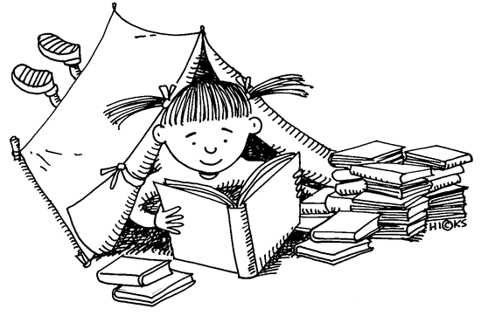

**Weather for the week of November 14-18**

|  |  |  |  |  |
| --- | --- | --- | --- | --- |
| MON. | TUES. | WED. | THURS. | FRI. |
| C:\Users\kashatuc.MCPSMD.017\AppData\Local\Microsoft\Windows\Temporary Internet Files\Content.IE5\KV52NGZX\MC900440405[1].png | C:\Users\kashatuc.MCPSMD.016\AppData\Local\Microsoft\Windows\Temporary Internet Files\Content.IE5\Q6LT7BM1\MC900432587[1].png | C:\Users\kashatuc.MCPSMD.017\AppData\Local\Microsoft\Windows\Temporary Internet Files\Content.IE5\1SN0OZYC\MC900438251[1].wmf | C:\Users\kashatuc.MCPSMD.016\AppData\Local\Microsoft\Windows\Temporary Internet Files\Content.IE5\Q6LT7BM1\MC900438251[1].wmf | C:\Users\kashatuc.MCPSMD.017\AppData\Local\Microsoft\Windows\Temporary Internet Files\Content.IE5\SF15W6S9\MC900440405[1].png |
| 72° | 66° | 60° | 51° | 50° |
| 58° | 53° | 41° | 31° | 35° |

*-By Jessica*

Social Studies / Science

# Regions of the World

We will be working on our regions research on Friday. We will be using the computer lab to use the online encyclopedias. Thank you, parent volunteers, for helping with this research!

We are learning about animal and plant adaptations in the desert, the rainforest, the tundra, grasslands and our own deciduous forest.

Math

Mrs. Kashatus’ class is working on linear measurement. We are converting inches to feet and yards.

Mrs. Noenickx and Ms. McGee’s classes are working on multiplication and division strategies.

Reader’s Workshop

We are learning strategies to understand nonfiction texts. This week we are looking at **cause and effect to understand text structure**. We made **cause and effect** cartoons.

***Ramona*  Book Review**

**Realistic Fiction**

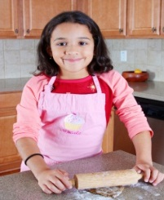 Ramona Quimby, Age 8 is about a girl named Ramona and her life in third grade. It is considered realistic fiction because there is no real girl, Ramona Quimby, who experienced the same events in the same sequence, but it could happen to a real kid. Some of us could relate to things that happened in the book. We would give this book four stars because it is mostly a good book but one part is bad. To find out what happens read the book yourself.

-By: Natalie, Ally and Becca ☺

Please remember to return empty report card envelopes!

### C:\Users\21404676.MCPSMD\AppData\Local\Microsoft\Windows\Temporary Internet Files\Content.IE5\M42XB3S1\MC900384368[1].wmf

# Independent Reading Book Reviews:

***Ice Fire*** is a fantastic book about David, the main character. He must uncover the thruth behind the mysterious clay dragons. David’s quest is to discover the link between the fire of the last known dragon on earth and the icy regons of the Arctic . It’s a journey that will bring him to the legend of dragons and the mysterious ancient secret of the ice fire… If you like fantasy, this is the book for you.

–By Brendan B.

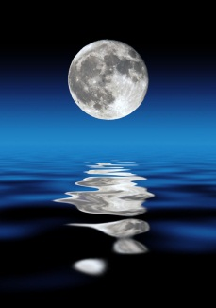The ***Amber Brown*** group is reading a book by Mary Pope Osborne, **Midnight on the Moon**. While we’re reading this book we’re collecting space facts! When we go to the plantetarium on December 6th, we will share our facts with the class! We want to tell you how the moon lights up. The sun lights up the part of the moon that it faces.

The characters in the book are Jack and Annie and they have a magic tree house and they choose any book and go there. In this book, they went to space and they were in the future and they built a moon base and it had a spacesuit room, airlock, rocket entry and a landing chamber. There is no air, no gravity and absoulutely no rain.We are on chapter 3. Joni chose this book. And, we like this book.

-By Joni and Joel

Writers Workshop

We read **Help Me Mr. Mutt**, by Janet Stevens and Susan Stevens Crummel. It was so funny and really good. Apparently the cat doesn’t like the book. We wrote our own advice column. Our ***Dear Green Thumb*** letters give tips to people with plant problems.

Mrs. Kashatus also read Cynthia Rylant’s book, **In November**. I’m really inspired by her. I could see those trees with no leaves. We had to write our own autumn poem. I also just finished her book, Snow. It was a ***‘have to read’*** book and I hope that everyone will think that. It is a great describing book. You could probably picture this book in your head, because I can. If you read it, you will get that white, soft feeling.

- This has been Jacqueline talking about writing.

Big News!

My name is Eva and I am live talking about a book called **In November**. It was like a sweet, peaceful lullaby.

In November the earth is growing quiet. It is making its bed, a winter bed for flowers and small creatures. The bed is white and silent, and much of life can hide beneath its blankets.

Don’t you think that was lovely?

I did- and remember, BIG NEWS! -By Eva

Art

In art, we are making collages and doing very creative art work. -By Scout

This week we will learn about Marc Chagall’s stained glass windows.