Mrs. Kashatus’ Brilliant Traveling Explorers

**2012**

**Around the World in 5 Days**

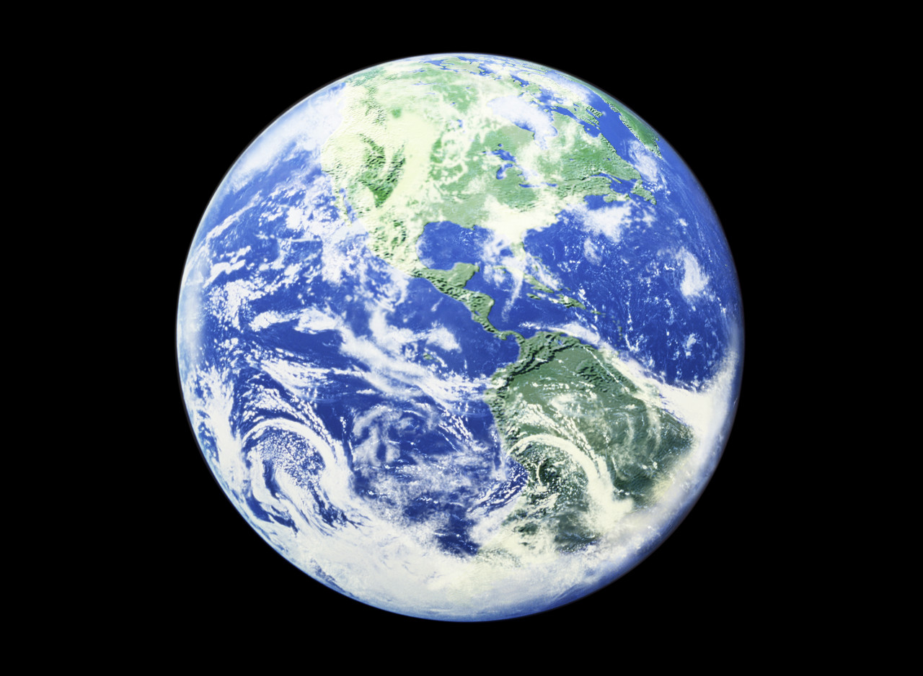

We have been traveling to regions of the world. Our intrepid reporters will share their research!

The Kashatus Chronicle mrskashatus.weebly.com

January 2012

[](http://school.discoveryeducation.com/clipart/clip/student-news-color.html)

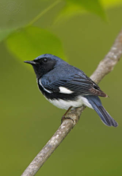The Kashatus Chronicle

**Regions: Around the World in 5 Days**

Stranded in the Deciduous Forest

If you were stranded in the deciduous forest, run to a clearing then make an axe by sharpening a piece of stone then attaching it to a stick. Then make a sword and / or spear and hunt a deer. Cook the meat, then cut down two flexible branches- but keep it kind of high and use the deer skin and drape it around the two branches and presto! A tent! Now hunt a bear and use the bear skin to make a hammock. That’s how people would survive with food and shelter in the deciduous forest. Ethan Ma

Birds, insects, mammals, reptiles and amphibians live in the deciduous forest. When the weather gets cold some animals some stay and some leave. Some stay and hibernate. Some stay active. Some migrate.

By Joel

I am a tree and it is really hard to be one in the deciduous forest. You have to fight for sunlight, water and minerals just to survive and your whole life is struggling. If you think your life is hard… try mine! Let me introduce my *friend* the walnut tree. He is horrible and mean and has no thought for the other plants. Did you know that walnut trees ooze poison when their roots suck up water, because the walnut tree can stand the poison and the other plants around it have no match and die and let the new seeds have an enormous amount of room to grow?

Also, being a tree we have to take control of so many leaves and we have to drop them just to survive and we only have a certain amount of time to do it so your branches will not freeze. I bet it’s harder being a tree than another plant!Spencer Caverly 12/19/11

Birds

**Birds in the deciduous forest have feathers so they won’t get cold. Birds have little feathers and they are light and they can fly. If they were heavy they would not fly. Birds are good flyers. Some birds fly faster than other birds. Some birds migrate and fly somewhere warmer where there is more food for them. Birds wait again for summer and they return to the northern forest to collect food and have babies. Melis Yanik 2/20/11**

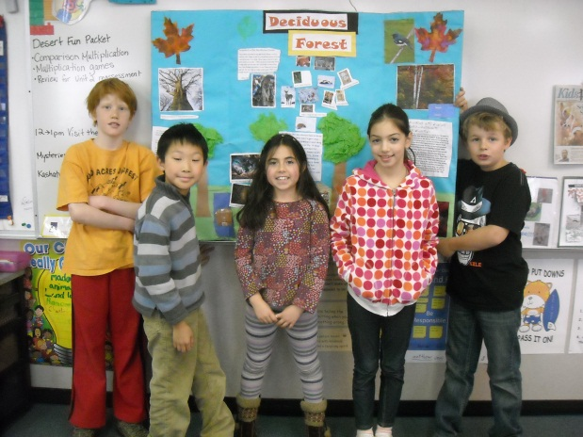AHHH! Few! I almost stumbled on a wood chip! My name is POP WEED, *POP WEED the PLANT*. If you go to the deciduous forest in the winter and you’re wondering why all the leaves aren’t on the branches of the trees, well it’s because the trees lose their leaves in fall. This happens because the tree is trying to prevent leaves and branches from freezing. Leaves need water but they will freeze during winter and so will their branches. So, the tree cuts the cord that then causes the leaf to drop on the forest floor. Then the tree will gather and store water in its roots for winter. Whoo- wee it’s a little chilly down here, because all the trees are covering up the sun for the other plants on the forest floor. Did you know that animals and plants work together to survive so they can gather food and make soil, birds help create the soil so do many other animals. I hope you enjoyed the visit! BY LILY ALIYEV DEC 19 2011

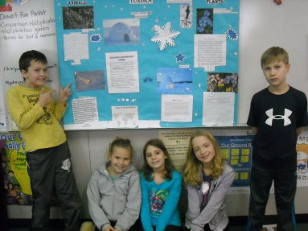**Let’s take a trip to the Tundra**

IF *You* were a Person in the Tundra

Hello, I am a person who lives in the Tundra. My name is Buniq, which means sweet daughter. It is very cold in the Tundra. In the summer the temperature is mostly in the upper 30s. In the winter it can drop under 32 degrees below 0 degrees F. You are probably thinking how I survive in the cold winters. Well, I wear a very heavy jacket and very fuzzy boots made out of seal skin. I also have a special baby blanket to help my sister stay warm. I almost forgot, a lot of people build igloos out of ice blocks. Igloos are very important because they keep the rain out and the heat in. It takes about 20 to 30 minutes to build an igloo. Building an igloo is not easy you have to find a lot of ice and then you have to bunch it all together into a thick short rectangle and make a bunch of them and keep on stacking until you made an igloo. You are probably wondering what we eat here. We eat fish and meat that we hunt. We mostly eat meat because we can't grow our own crops thanks to the permafrost. You don't even know what permafrost is. It is frozen ground that prevents big plants from growing. Sometimes permafrost can be over 1,000 feet deep! Wait! Just stop reading right there. Think about the question I am about to ask! *What if you had to do this and you almost froze on the top of the world!* The Tundra is located on top of the world. Do you think you would like it up here?  Well, I have to go hunting. . . Bye!

By: Evangelina Bertolotti 12/27/11

IF YOU WERE A PERSON IN THE TUNDRA

C:\Users\kashatuc.MCPSMD.017\AppData\Local\Microsoft\Windows\Temporary Internet Files\Content.IE5\EGLBWJGM\MC900338774[1].wmfAnd you had to make an igloo guess how long it would take? Oops I forgot to introduce myself! My name is Iggy Igloo but seriously guess how long it would take you to make an igloo ***BUZZ!*** Did you hear that? That means you got it ***WRONG! TOO BAD FOR YOU!*** The correct answer was 20-30 minutes! What now you’re telling me you got it right? I don’t believe it you must be ***LYING!*** Well actually the buzzer does that to everybody so you could have gotten it right. Now back to the igloos. Also the beds are made out snow blocks covered with fur. Also the igloo is made out of snow blocks stacked in a dome shape. So now you want to know why it is made in a dome shape. It is made in a dome shape because when it is in the dome shape it is stronger and because it is useful when the people who live inside me have limited resources. It is fun being an igloo because rain tickles me when it rains because the rain dosen’t go through me. By Matthew Lennie 12-19-11

Tundra Plants

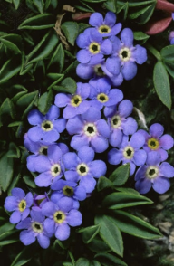 *Tundra plants are small and grow in clumps. They are dark colors to absorb solar heat. There roots are chilled by the permafrost. There stems get pushed by the icy wind. How do they get food and water? Do they die trying? No. Most actually make it! But they have to grow fast. That is because there is a very short growing season. What do you think? Zachary L. 12/16/11*

If you were a flower in the tundra trying to keep warm from the cold, icy winds blowing on you, what would you do? Well, I have been studying a lot about plants in the tundra so I can answer your questions. So, you might be wondering how plants survive. Well I can answer that! Their leaves are big and dark and they attract sunlight. The leaves have to be as dark as possible so that they can capture solar energy. Also, plants in the tundra have very short stems and they grow close together to survive cold winds. Mosses and lichen grow in clumps on rocks. One of the most popular flowers is the ***alpine forget-me-not***. It has dish-like flowers to attract sun. So I hope that answers all your questions! By Katelyn

Tundra animals

Hi I am Joni and today we are going to talk about three tundra animals. First let’s talk about a snowy owl. A snowy owl can camouflage from white fur to brown fur and it even has fur on its legs to keep its babies warm. They live under ground in burrows to keep warm. Now let’s talk about lemmings. A lemming can camouflage from brown fur to white fur. They live under ground in burrows. In the summer they grow huge claws. Now let’s talk about an arctic hare. Arctic hares can camouflage from white fur to brown fur an artic hare lives in burrows. They can protect themselves in the winter by hiding in the snow and predators can’t see them. These are the true facts about tundra animals.

By Joni December, 16 2011

If you were a baby wolf pup in the tundra things would be challenging. How would you like to be a baby wolf pup that had just been born and you can’t see, hear or smell for about 1 or 2 weeks? I would think it wouldn’t seem nice. Their fur is thick so they can survive in such a harsh climate. Now here are some facts about lemmings. How would you feel to be a lemming and have to stay by your burrow so when predators come you would crawl right in? But one good thing for lemmings is that their fur turns from brown in the summer to white in the winter to help them camouflage. Their claws turn short in the summer to long in the winter to dig snow. Now on to the last animal: a snowshoe hare. Snowshoe hares also change their fur from brown in the summer to white in the winter. This helps them to survive their predators. So now you can see how hard it is for animals to survive in the tundra. Fortunately, they have adaptations to help! Ally 12/16/11

WELCOME TO THE

**Rainforest**

I’m Josie, your tour guide for today.

Now let’s explore! Here is a rainforest house. As you can see, it is made of branches, straw, bamboo and leaves. Oh, hello. You must be the owner of this house. I very much like your feather headdress! Is today a special occasion? Oh, I’m sorry. I forgot that you people of the rainforest don’t speak English.

Good-bye for today.

Let’s get some lunch! I sure am hungry! Here’s the menu: Bananas, berries, gum, nuts… there’s a smaller menu than I thought! Did you know that gum is made in the rainforest? OUCH! This sun is hot! I wish the rainforest wasn’t near the equator. Watch your step! Huge rain puddle ahead! Watch your step, watch your step… wow! Look at that! What a beautiful waterfall. The rainforest sure has lots of nature! Oh, well. Looks like the tour is over. You may go to your plane now. At least we got to see some cool rainforest stuff!

Fun Fact: Chocolate and vanilla are from rainforests.

GOOD-BYE!!! By Josie

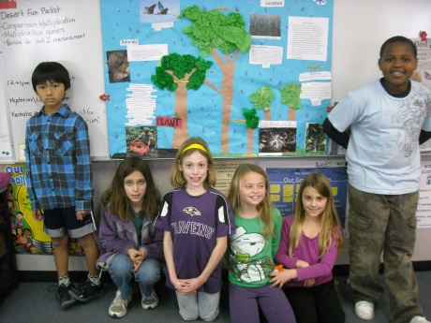Imagine you are walking through the tropical rainforest. You might feel the soggy, dark brown forest floor beneath your feet; the leaf litter makes the soil moist, green and full of food for other plants. You see strangler trees roots climb up trees. The roots are surrounding the tree it is strangling the tree it is begging for air. You also would see bright plants. Do you know that bright plants attract birds and insects? If you listen really closely then you would hear little pitter patters of insects. For birds you would hear little soft voice of singing.

By: Jacqueline 12/16/12

C:\Users\kashatuc.MCPSMD.017\AppData\Local\Microsoft\Windows\Temporary Internet Files\Content.IE5\2PUTBRTE\MC900434565[1].wmfHello, my name is Mrs. Sloth. I am six years old and I live in the rainforest. When we are baby sloths we cling to our moms for nine months till we can live on our own. We are slow but it pays off because we are great swimmers. We are so slow, algae grows on us. This is how I camouflage in the rainforest. *What is life like for you?*  BY: Natalie DeSarbo Dec\19\2011

***Hi my name is Jessica and I’m your tour guide.***

P.U! What is that HORRIBLE SMELL?!?!?!?!

Well that is the largest flower in the world and now you don’t have to research what it is . . .

***IT’S THE RAFFLESIA!!!!!!!!!!!!!!!!!!***

YES, the RAFFLESIA is the largest flower IN THE WORLD but also, it is a very VERY RARE plant. The RAFFLESIA ONLY- YES I said it-**ONLY** grows in Indonesia and if you do not know where Indonesia is it is in Southeast Asia.

C:\Users\21404958.MCPSMD\AppData\Local\Microsoft\Windows\Temporary Internet Files\Content.IE5\M42XB3S1\MC900423163[1].wmfThe RAFFLESIA blooms on the forest floor and smells like 10 DAY OLD ROTTEN MEAT OR A 10 DAY OLD DEAD CAT”!” Wouldn’t it be sad if a RAFFLESIA was a dead cat??????

The RAFFLESIA ONLY lives 1 WEEK and then dies. The RAFFLESIA is THREE FEET ACROSS AND WEIGHTS 25 POUNDS THAT’S MORE THEN A BEAGLE!!!!!!!!!!!

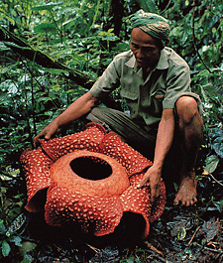The RAFFLESIA’S stink attracts fly’s to spread it’s pollenate to other RAFFLESIA’S .

Well I got to go but I hope you learned something, BYE!

-JESSICA YOUR TOUR GUIDE!

rafflesia

Rainforest people

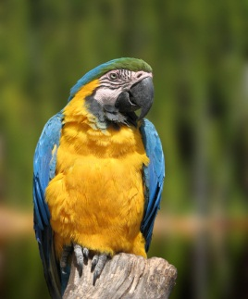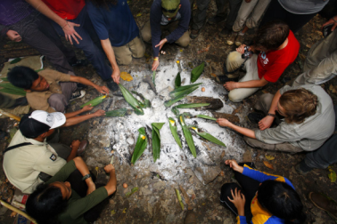Welcome to the tropical rainforest! I am Joshua your tour guy and I will tell you amazing facts about people of the rainforest. Let’s visit the homes of the rainforest. Rainforest people build their homes by using materials they can find nearby. The **yanomani** people live in the amazon. They build enormous huts called **malocas.** Many families share one maloca. Let’s go see how rainforest people make their food. Rainforest people hunt or grow most food they eat. **Manioc** is a vegetable that is eaten by most rainforest people. It can be eaten in many different ways. People grate and pound manioc before roasting it. Manioc flour can be made into bread or pancakes. Well it looks like times up have a nice day.

By: Joshua Mwangi 12/19/11

Hello my name is macaw & I live in the rainforest & I eat nuts. I use my beak to open them. By:Maito

In the grasslands, the people build houses out of materials they find like sticks, twigs, straw, and grass. The grasslands people wear light clothes so they won’t get to hot. In temperate grasslands they have cold winters and hot summers. Some other names for grasslands are **pampas, veld, steppes,** and **savannas.** Grasslands are located in every continent except Antarctica and the North Pole.

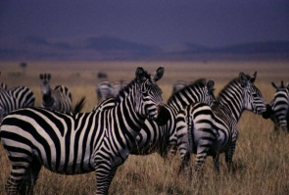By: ZACHARY SAFFORD

**Wild Animals**

**In the Grasslands**

Here in Africa the savannas are like a bowl full of life. Wouldn’t you like to go there? Yes, come, let’s go…

Here the birds sing the, snakes hiss and the flowers swing in the breeze. OH NO! There are lions. I forgot to mention. Duck in the grass with the zebras. I’ll tell you why, it’s because zebra’s stripes help them hide in the grass. They look like shadows. Oh brother! They have spotted us! RUN!

We outran them!

Look! Baboons doing their own little cha cha! Come on, let’s go get some water by that pond.

STAND BACK!

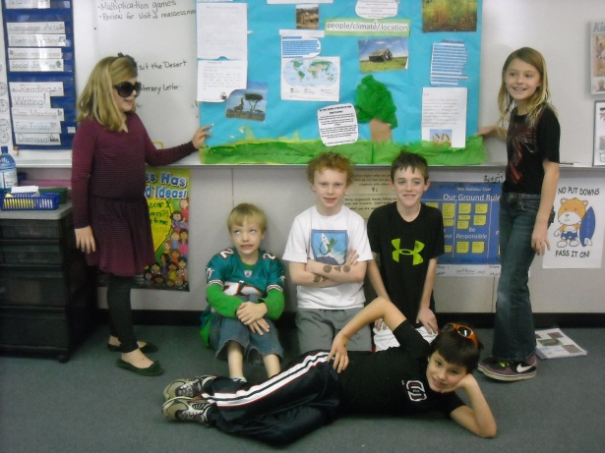There’s a hippo and I think he’s claimed the WHOLE pond! Ahh! I see lions! Run to the trees! This is what giraffes do and they look like trees. They also get snacks from tall branches.

Imagine that YOU were an animal in the grasslands. You’d have a lot to worry about. Fortunately, you’d also have adaptations to help you survive!

Let’s go back to the plane! Bye!

-by Eva Levy

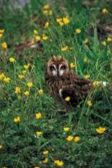Burrowing Owl

Burrowing owls are found in the ground where they nest.

They move into prairie dog, gopher and woodchuck burrows. Burrowing owls eat mice, rats, pocket gophers, chipmunks, shrews, lizards, snakes, crayfish, frog, toads and fish. People threaten them by poisoning their food. By: Brendan B.

**BAMBOO CAN BE USEFUL BECAUSE YOU CAN MAKE HOUSES, CHOPSTICKS AND FENCES AND OTHER STUFF. YOU COULD MAKE CEREAL FROM ONE OF THE MANY GRAINS SO YOU DON’T STARVE AND YOU COULD PUT SUGAR IN YOUR CEREAL IF YOU FOUND SUGARCANE JUST TO ADD FLAVOR TO YOUR CEREAL AND THEN CONTINUE YOUR HOT JOURNEY.**

**ZEBRAS MAKE GRASS GROW STRONGER BY GRAZING.**

*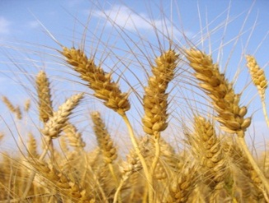***STINGING NETTLES SURVIVE BY GIVING THERE PREDATORS A STING. BRENDAN SULLIVAN**

**Wheat** grows in several continents it was brought to this country by early American settlers. Its root system adapted to the rich soil because of its stable roots. **Wheat** grows in the states of Kansas, Nebraska, Iowa and Oklahoma. **Wheat** also adapts to the grassland because it’s a cousin to the grasses there. By Scout

IF YOU WERE A PERSON IN THE GRASSLANDS

If you were a person in the grasslands you would raise cows and goats for milk and meat.

If you were a person in the grasslands you would have to pick cotton for clothes.

And if you were a person in the grasslands your house would be made of sticks, mud, twigs and almost any other materials you could find.

Grasslands are located in every continent but the north pole and Antarctica

By Geoffrey

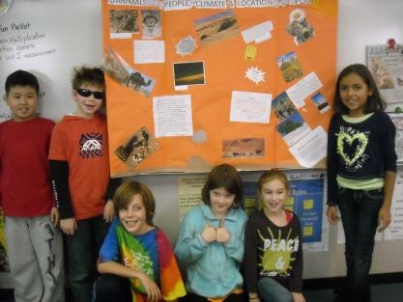**DESERT**

When someone says DESERT, you may think of sand, sun, no water and cacti. But there is way more! **TRUST ME!** A desert is a place that’s really dry, usually sandy, with few plants but it has more plants than cacti. Desert people wear cloaks- but not Harry Potter cloaks-cloaks that cover your body and keep you cool and protected from blowing sand and hot sun! -By Juliana 1/6/12

Plants in the Desert

If you were a plant in the desert and there was just a rainfall, think of how refreshing you would feel. You would go from being so hot and dry to so nice and wet. Now take a look around you, the desert seems more like a garden than a desert. The hillsides are ablaze with yellow blossoms, and the beautiful cacti and other desert plants make the desert look perfect! All of the plants make the desert not seem like the open sandy place that some people might imagine.

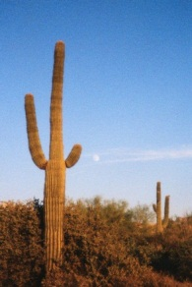But it doesn’t rain very often in the desert. So it is very important that the plants store water. Some desert plants, such as the Mesquite Tree, have long roots that reach water deep down under the ground. But some plants, like the cactus, stores water in their stems because they don’t have long roots. Life in the desert can be really hard, but somehow plants know how to survive. By Sammy 12/21/11

You might think being a desert plant is like squeezing a ***lemon***, but it’s not. Desert plants have special ways to survive in the hot, and dry lands. Many cacti like the Barrel cactus and the Saguaro Cactus store water. The Saguaro Cactus is also tall and it grows flowers. The Prickly Pear Cactus uses its shallow roots to collect water, its bright yellow flowers bloom open, and they have sharp spines to keep thirsty animals away. The Joshua Tree’s leaves do not fall off, it grows in the Mojave Desert and the leaves on it will die if the water’s gone. That’s all the things I’m going to tell you.

By Yipu Yu 12/16/11

Elf Owls

Hi! I’m Elfie the Elf Owl. Imagine if you were an Elf Owl in the desert, trying to find a home. We hunt and are awake during the night (that means we are nocturnal). Not only can we see better but our prey is out during the night to avoid the heat. An elf owl’s life is pretty hard. We have to find a home, in a cactus- that was already made! But just imagine you’re the smallest owl of all owls. You’re only 5 inches long.

Did you know that if you were an owl you would have to live with a third eyelid? But you could only use it for cleaning your eyes. For many owls, one ear is higher than the other on their head. The higher ear hears sounds from above and the lower ear hears sounds from below. As you can see it’s not easy being an Elf owl. By; Rebecca Martin-Welp 12-16-11

IMAGINE DESERT ANIMALS

Imagine being a **Gila Monster** surrounded by little grains of sand. You would not drink much and you would have to store food and water in your tail. How would you feel? Imagine being a **camel.** Desert people ride you and use you to carry things almost all the time. How would you feel? Being a rattlesnake must be even harder- gliding over the hot sand. Also imagine being a dingo hunting down other big mammals. Will you like it? Will you not? You’ll only know if you try. Also imagine being an **owl** in the desert- living in a cactus. Will thorns reach you? If they do, what will you do? How will you react? Would you panic-or not? Last but not least, imagine being a desert fox blending in with the sand. You would be able to sneak up on prey! It’s not easy being an animal in the desert, but they all adapt! By: Thiago 12/19/11

So, what`s the DESERT? Well it’s a piece of land that gets very little rain, 10 INCHES A YEAR!!! There are hot deserts and cold deserts, and the hot ones get down as low as 30° at night! A lot of the time in the hot deserts it gets up to 120°! The people wear cloaks that keep them cool. Sometimes their houses are built into hills and sometimes not, the ones that aren`t are called: **HOWIS.** So that’s what a DESERT is. By: Peter 12\23\11