[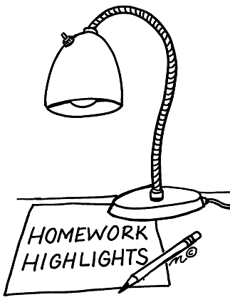](http://www.google.com/url?sa=i&rct=j&q=&esrc=s&frm=1&source=images&cd=&cad=rja&docid=JV7kRU8BaZ3mhM&tbnid=w6gKrYDUkFDYgM:&ved=0CAUQjRw&url=http://school.discoveryeducation.com/clipart/clip/homework-highlights.html&ei=PrU5UsvPIril4AO11oHYBA&bvm=bv.52288139,d.dmg&psig=AFQjCNHxVvJ2bLd14fGZnVu9aVPGtMVTvA&ust=1379600045680721)Mrs. K.’s Word Study Homework

Name _______________________________________

Day of Test/Due Date**: November 14, 2014**

Parent Signature ______________________________

* **During the two-week word study cycle, complete at least five of the activities listed below. If an activity requires writing, use the designated space below or on the back of this sheet.**
* **Check off each activity you complete and have your parents sign this sheet.**
* **Return this page to school on the due date.**
* Cut and sort your words in the same categories you did in school. (**required**)
* Speed sorts: Sort the words again quickly. Time yourself and try to beat your time!
* Blind sort: Have someone lay down a word or heading from each category, and then read each word aloud as you point to where the word goes without seeing it.
* Writing sort: Write your words in categories.
* Word hunt: Look in a familiar book or magazine for words that have the same sound, or pattern, or both. Write the categories you discovered from your writing sort. Write the new words below it. Try to find two or three words for each category.
* Sentences: Write sentences with five of your words to show you understand their meaning.
* C:\Users\noenickt.MCPSMD.018\AppData\Local\Microsoft\Windows\Temporary Internet Files\Content.IE5\RGFUL8XM\MC900384132[1].wmfNo-Peeking Writing Sort, also known as a practice test. Have someone call out the words as you write them in categories. Check your spelling and correct any words you missed.

Writing Sort: Write your words in categories. Include category titles!

________________________________________________________________________________________________________________________________________________________________________________________________________________________________________________________________________________________________________________________________________________________________________________________________________________________________________________________________________________________________________________________________________________________________________________________________________________________________________________________________________________________________________________

C:\Users\noenickt.MCPSMD.018\AppData\Local\Microsoft\Windows\Temporary Internet Files\Content.IE5\KEE4U1MD\MC900440450[1].wmfWord Hunt: Try to find two or three new words for each category from your word sort.

______________________________________________________________________________________________________________________________________________________________________________________________________________________________________________________________________________________________________________________________________________________________________________________________________________________________________________

Sentences: Write sentences with five of your words to show you understand their meaning.

1. ____________________________________________________________________________________________________________________________________________________________________
2. ____________________________________________________________________________________________________________________________________________________________________
3. ____________________________________________________________________________________________________________________________________________________________________
4. .___________________________________________________________________________________________________________________________________________________________________
5. ____________________________________________________________________________________________________________________________________________________________________

No Peeking Writing Sort (also known as a “practice test”)

1. ________________________

2. ________________________

3. ________________________

4. ________________________

5. ________________________

6. ________________________

7. ________________________

8. ________________________

9. ________________________

10. ________________________

11. ________________________

12. ________________________

13. ________________________

14. ________________________

15. ________________________

16. ________________________

17. ________________________

18. ________________________

19. ________________________

20. ________________________

21. ________________________

22. ________________________

23. ________________________

24[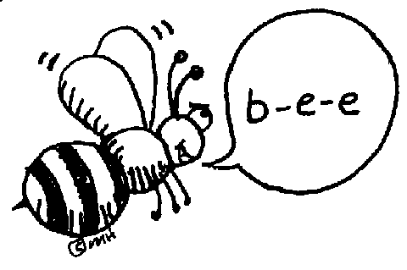](http://www.google.com/url?sa=i&rct=j&q=&esrc=s&frm=1&source=images&cd=&cad=rja&docid=uqz2fWyUSflovM&tbnid=BntYL9ocoG0lJM:&ved=0CAUQjRw&url=http://school.discoveryeducation.com/clipart/clip/spelln-b.html&ei=KbY5UsqnFPa-4AOv0YGQAg&bvm=bv.52288139,d.dmg&psig=AFQjCNEI92mgoQXEi9utTFtUrfbs3xgSwQ&ust=1379600276647204). ________________________